Step 1: open eclipse application

Step 2: click on file, go to new and click on maven project

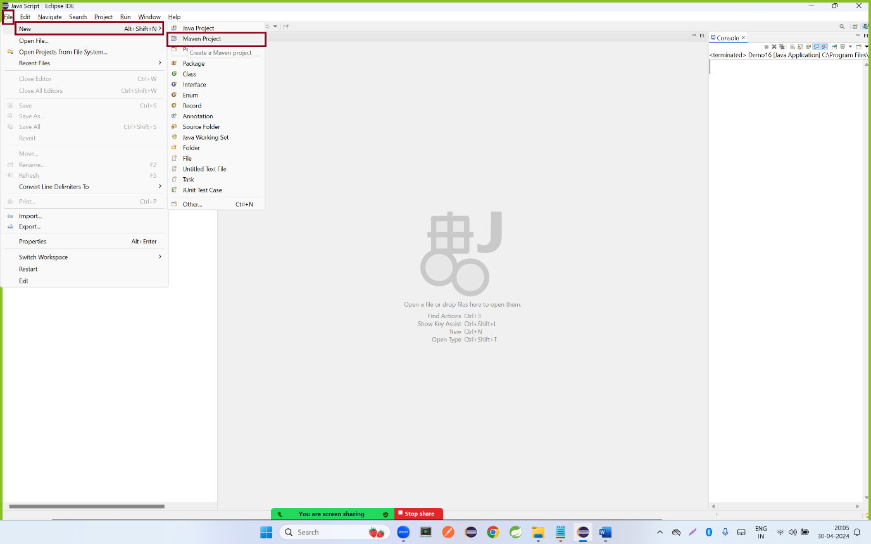

Step 2: click on Next button

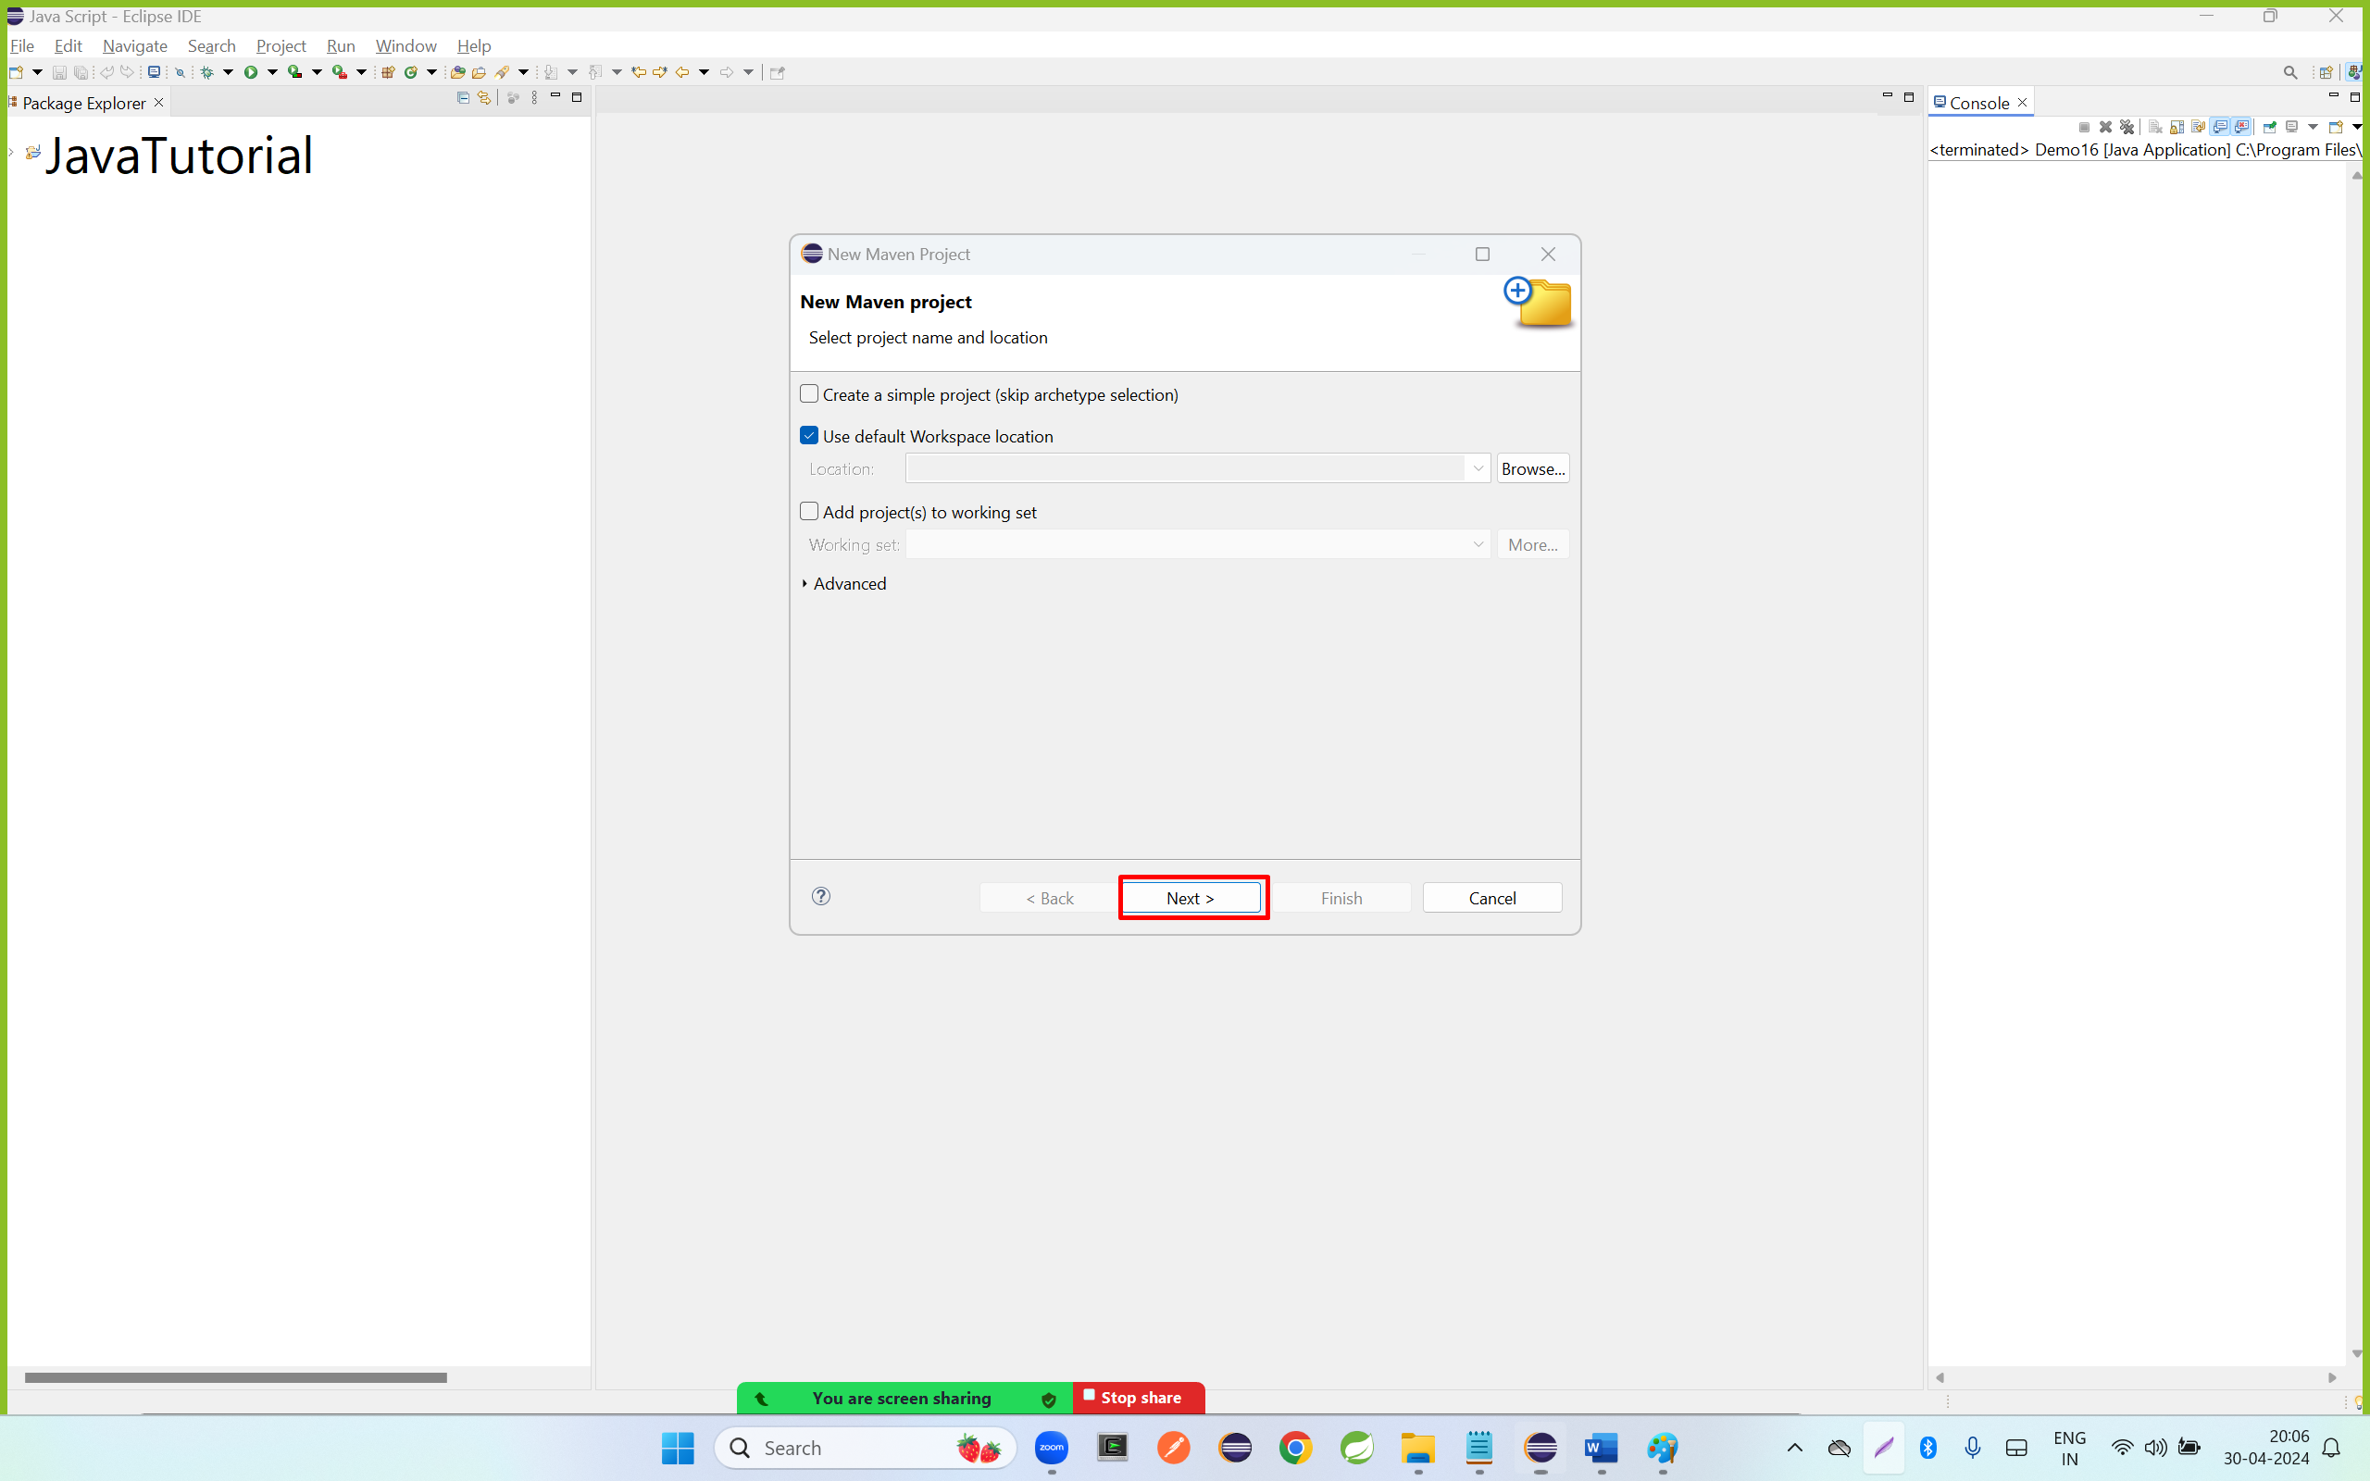

Step 3: Select internal options from catalog and select the maven-archtype-quickstart 1.1/1.4 and click on next button

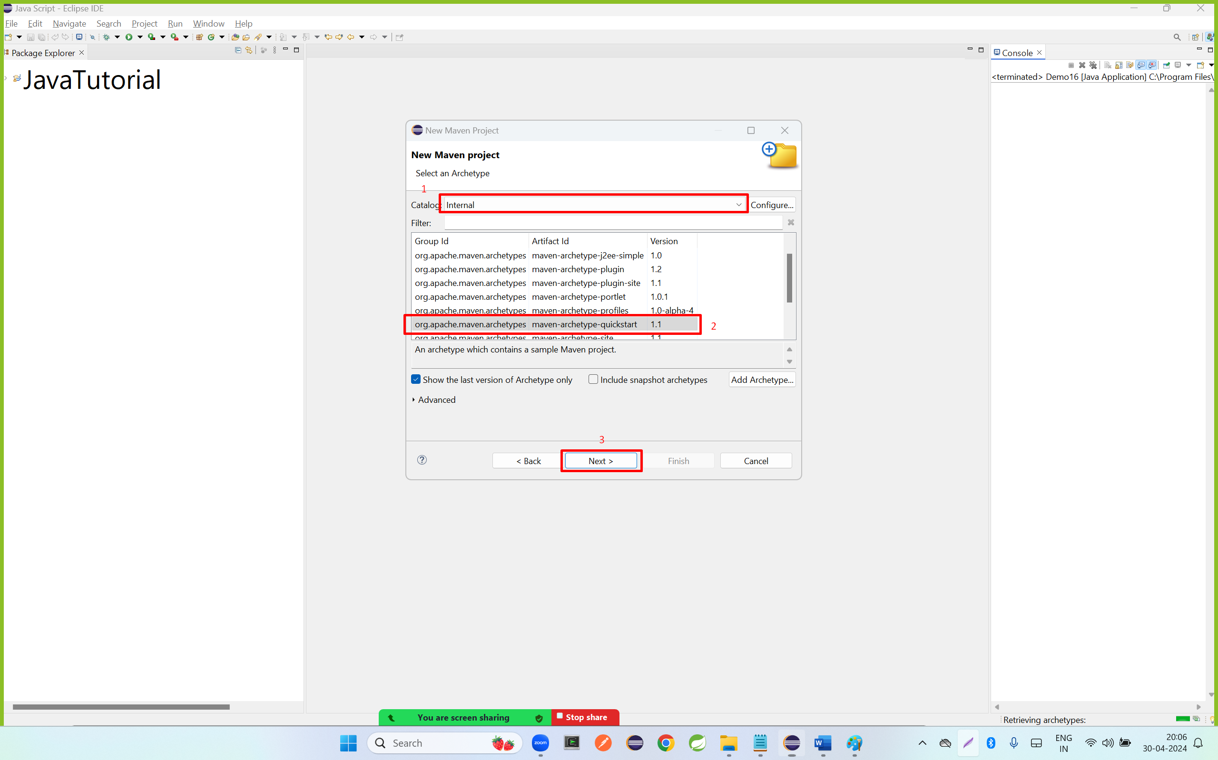

Step 4: enter group id and artifact id and click on finish button

Group id nothing but the package name

Artifact id nothing but the project name

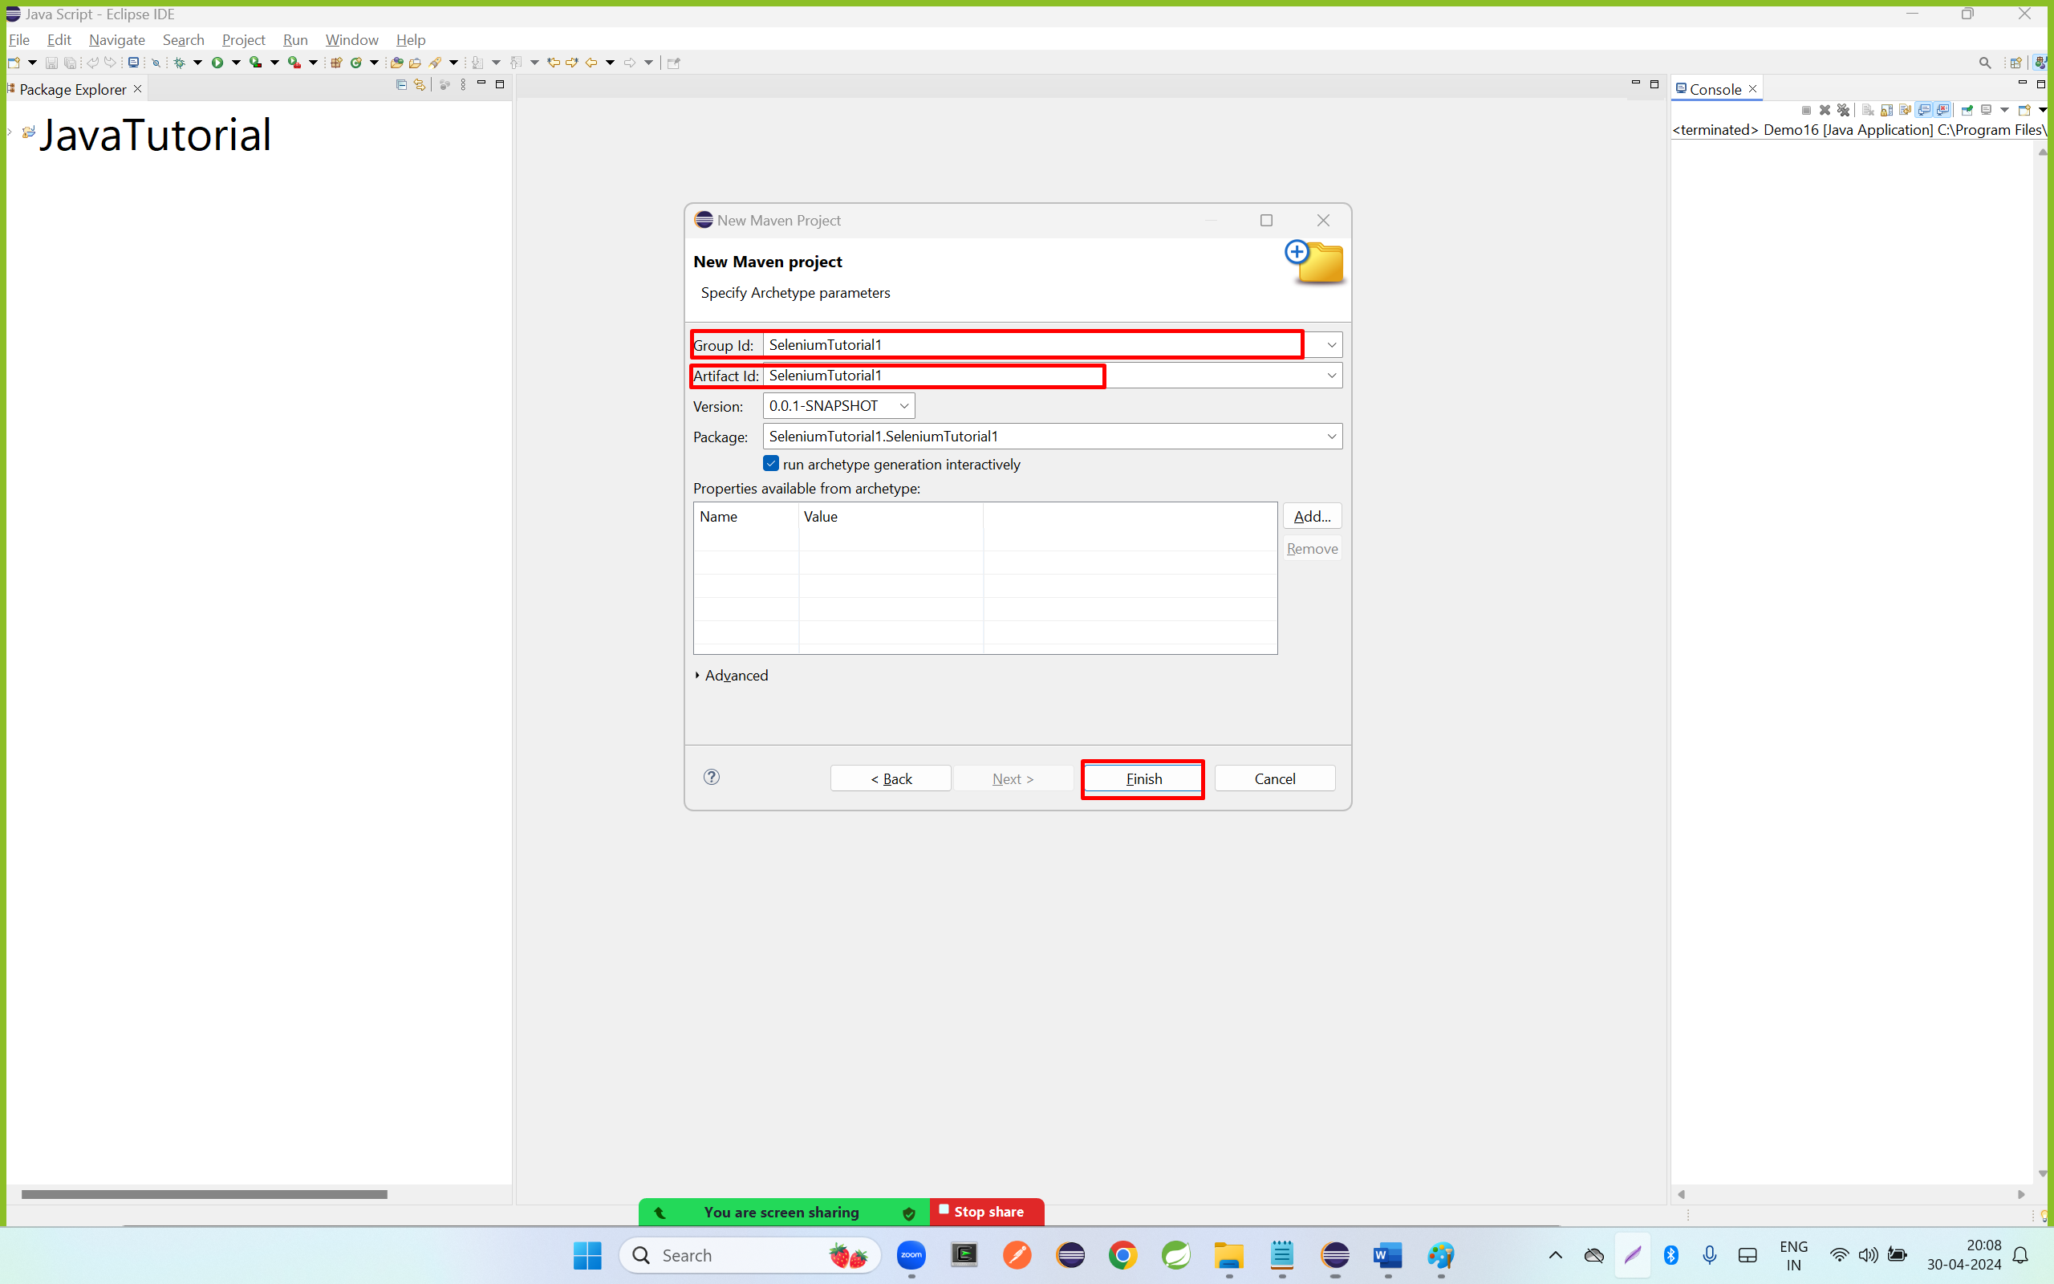

Step 5: go to console and enter y keyword

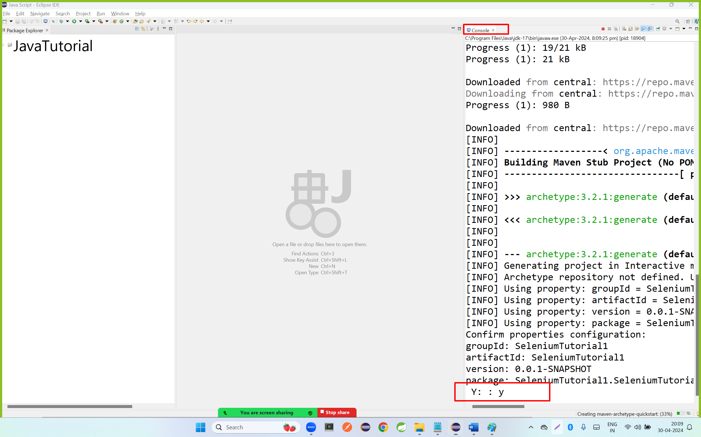

Step 6: click on less than symbol or double click on project

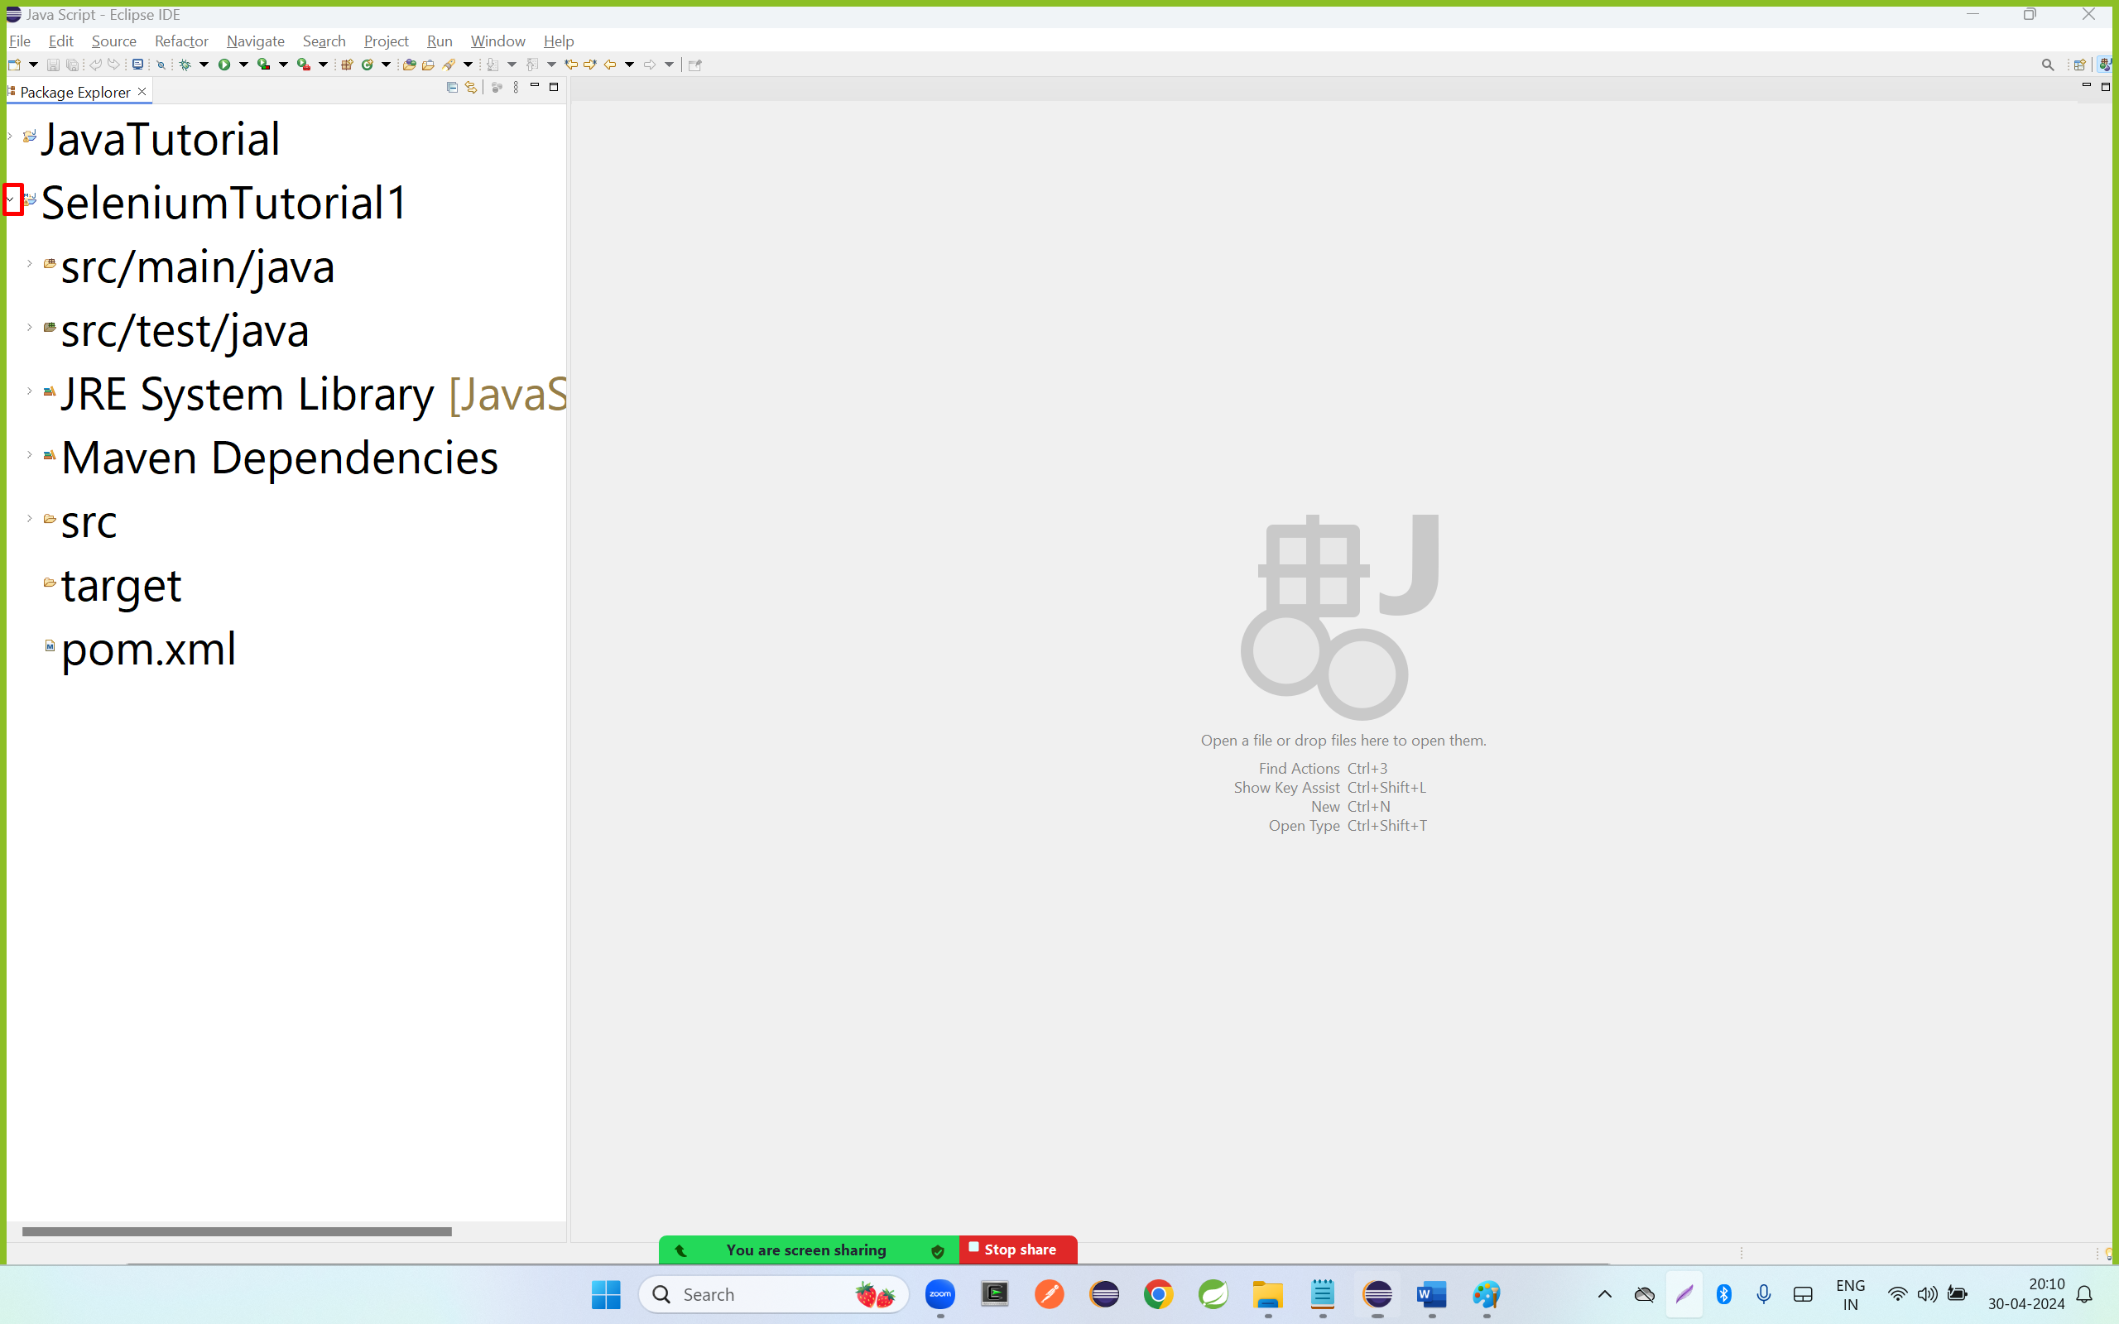

Step 7: double click on pom.xmlf file

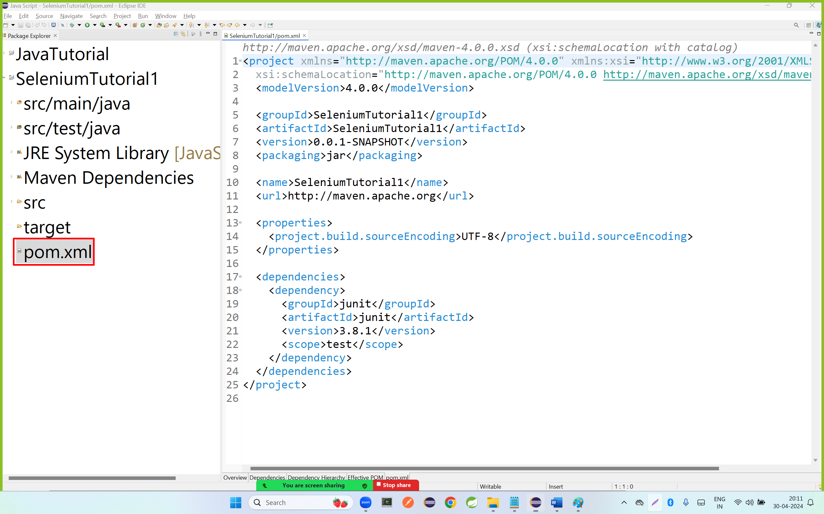

Step 8: copy the below dependency or library and paste in pom.xml file as per below images

|  |
| --- |
| <!-- https://mvnrepository.com/artifact/org.seleniumhq.selenium/selenium-java -->  <dependency>  <groupId>org.seleniumhq.selenium</groupId>  <artifactId>selenium-java</artifactId>  <version>4.16.1</version>  </dependency> |

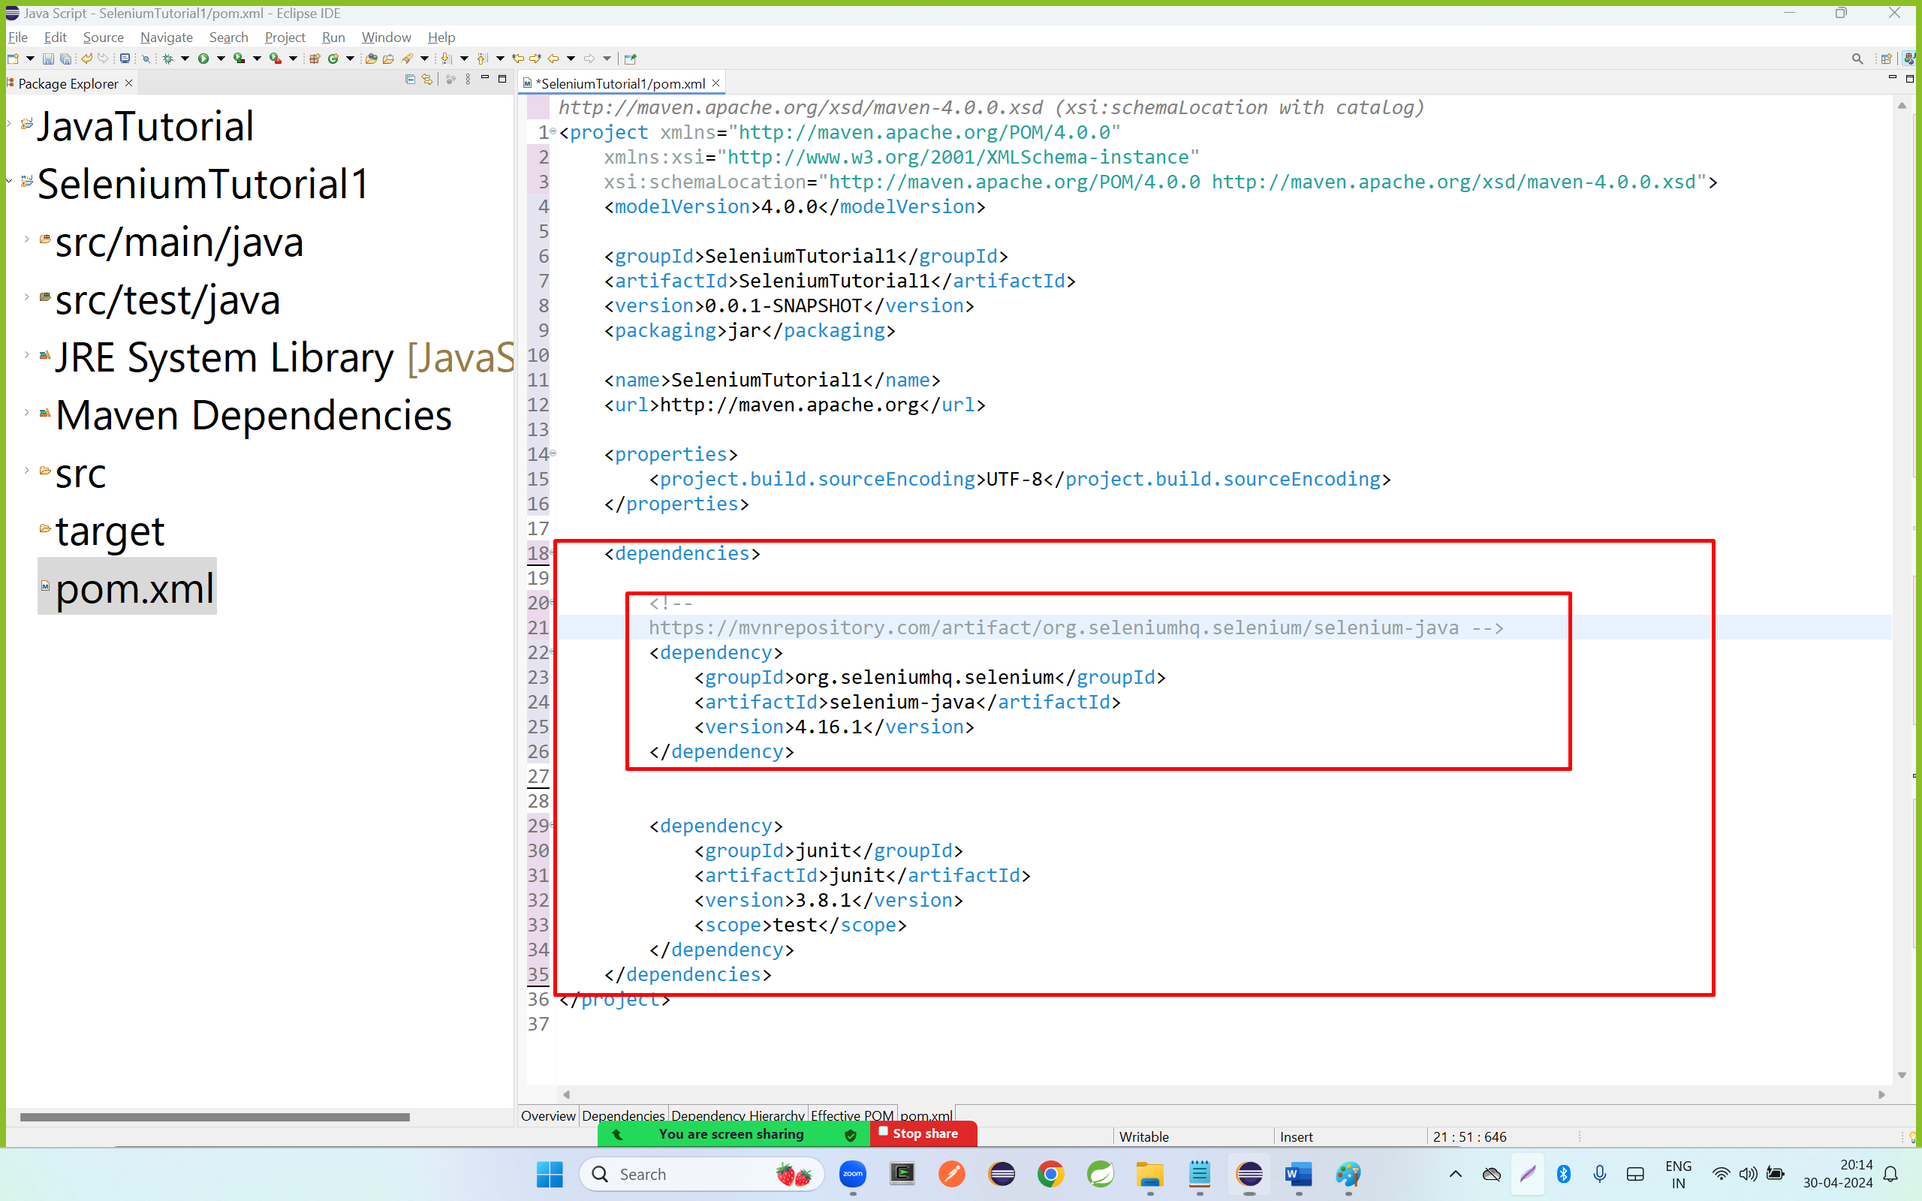

Step 9: close pom.xml file

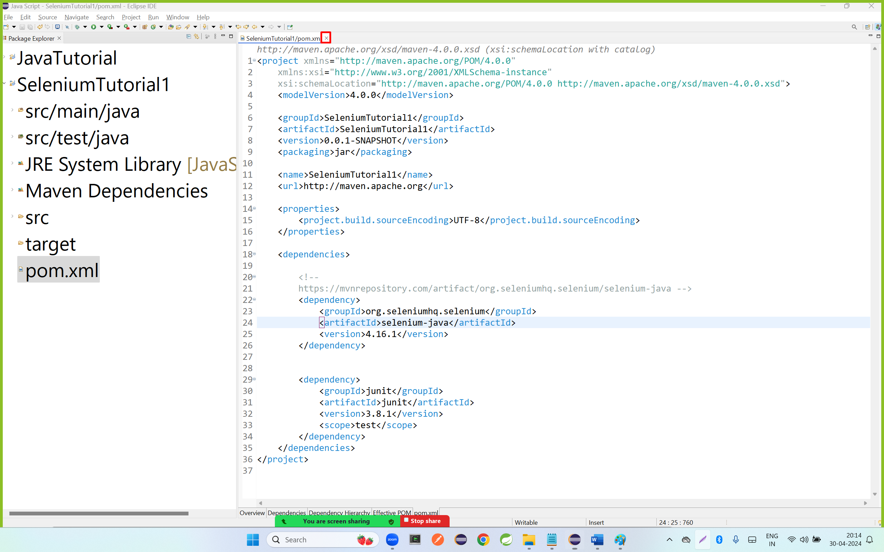

Step 10: right click on src/main/java go to new and click on package

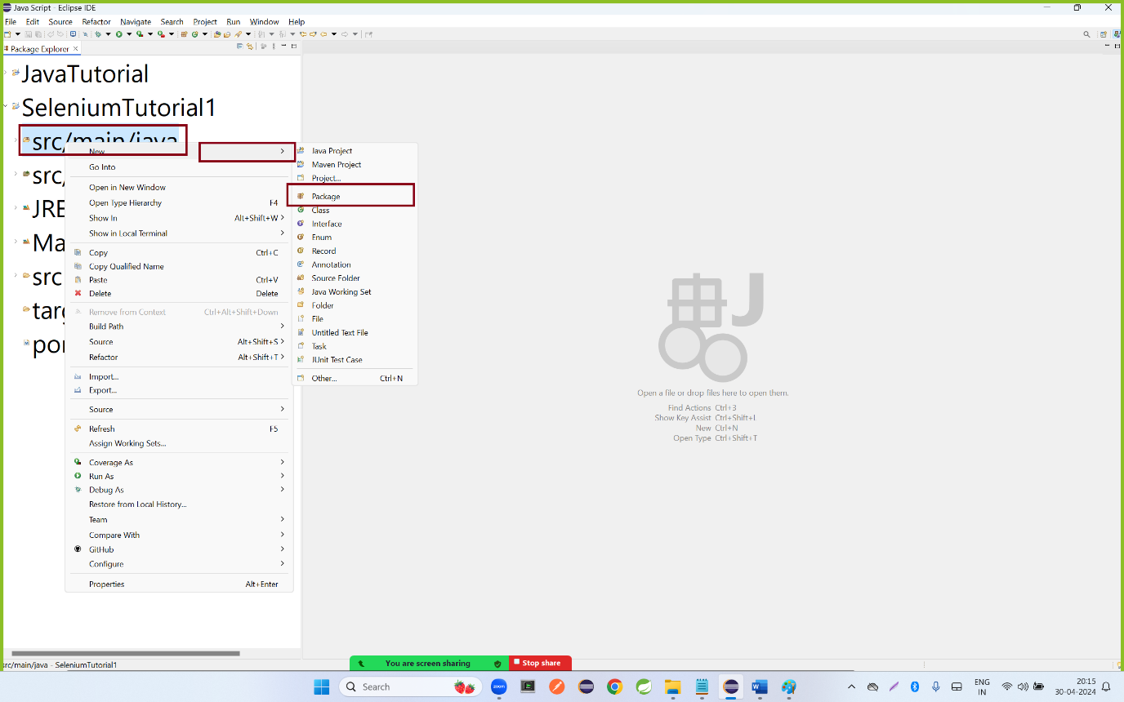

Step 11:enter the package name and click on finish button

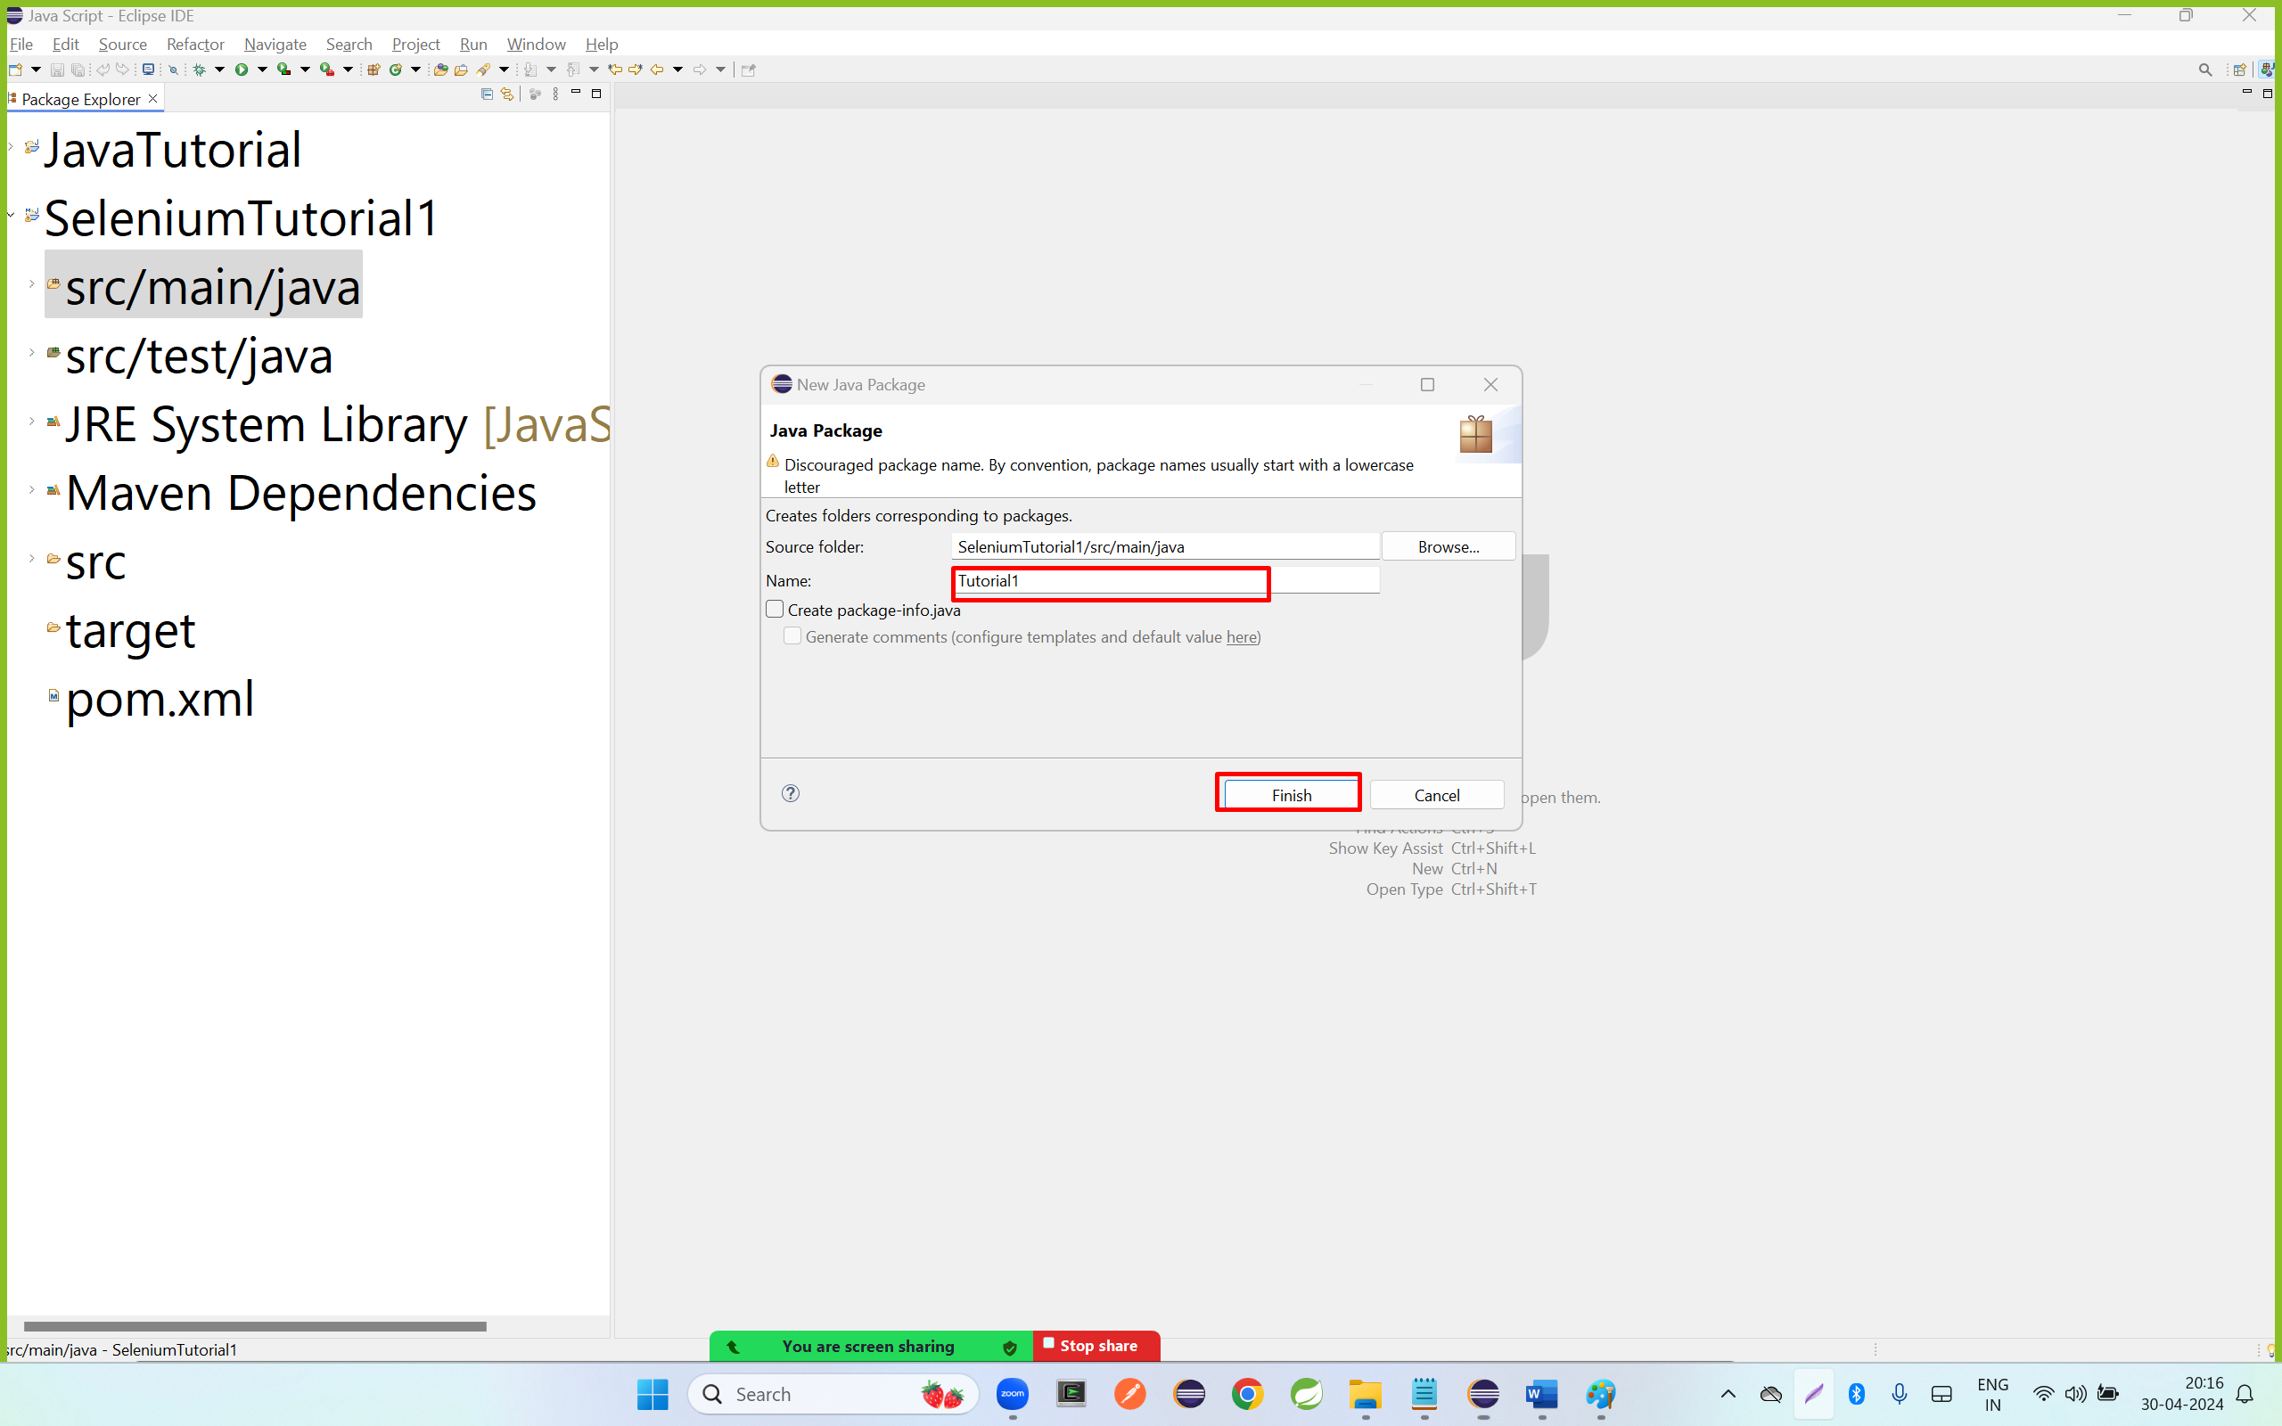

Step 12: right click on tutorial1 package name and go to new and click on class.

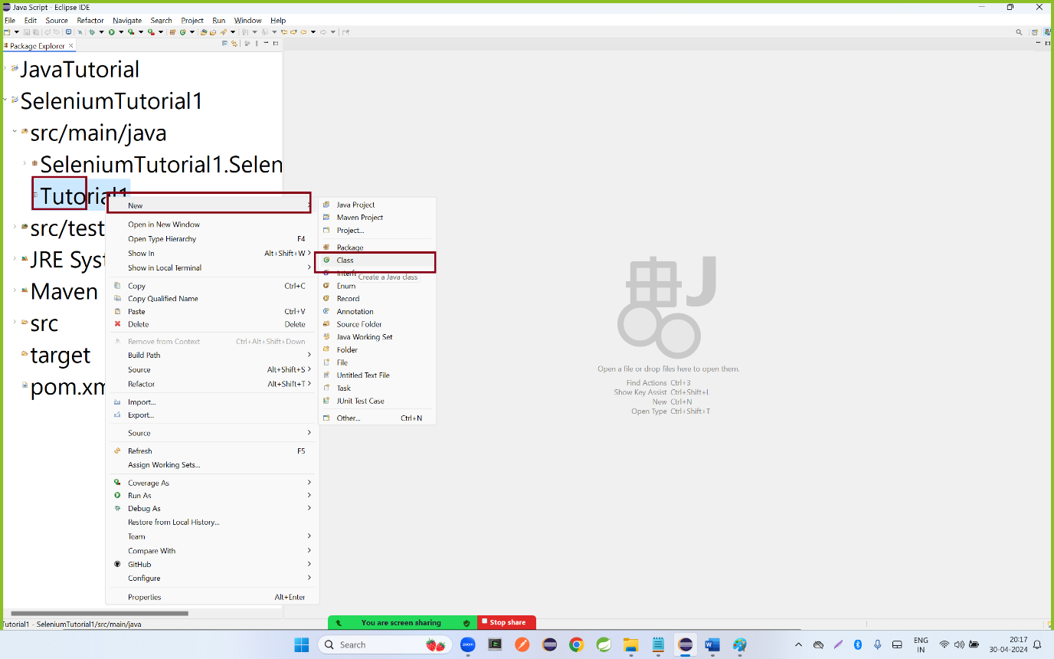

Step 13: enter the class name and select the main method and click on finish

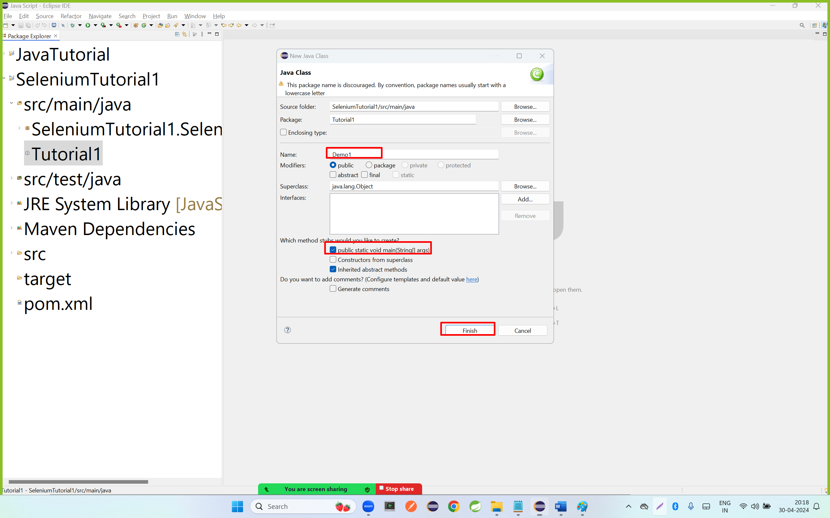

Step 14: copy the below code

|  |
| --- |
| **package** Tutorial1;  **import** org.openqa.selenium.WebDriver;  **import** org.openqa.selenium.chrome.ChromeDriver;  **public** **class** Demo1 {  **public** **static** **void** main(String[] args) {  // press control+shift+o  WebDriver driver = **new** ChromeDriver();  // get() method is used to open a specified url in browser window  driver.get("https://www.redbus.com");  }  } |